SUNY Broome - Macroeconomics
Exam #5 – Review Sheet
CH. 18-20

Chapter 18 – International Trade and Finance
- Consumption Possibilities – productions possibilities
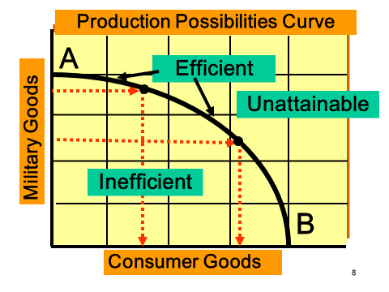
- specialization and trade
- comparative v. absolute advantage
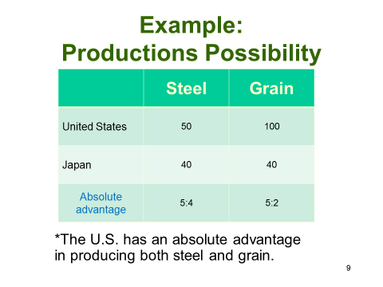

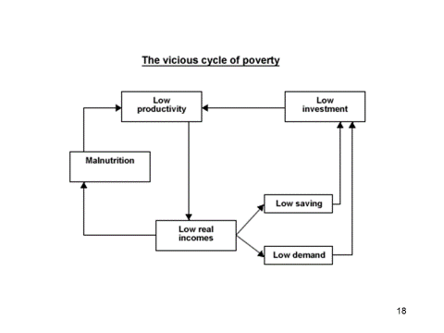

- trade barriers – quota, tariff, and embargo
- infant industries
- favorable balance of trade
- exchange rates and depreciation

Chapter 19 – Economies in Transition
- 3 basic economic questions – WHAT, HOW, FOR WHOM to PRODUCE?
- Traditional, command, market, and mixed economies
- Adam Smith – capitalism, laissez faire, “invisible hand” theory
- Karl Marx – socialism, communism

Chapter 20 – Growth and Less Developed Countries
- per capita GDP
- LDC’s and IAC’s – factors of each
- What is infrastructure?
- What is economic growth?
- vicious Cycle of Poverty

